Sprint 9 Status Report
For the Girl Scouts of America Badge Tracking
Application

By
Matt Eck
Michael Glosecki
Nathan Martz
Ryan Schroeder

Of
Team Cookie Council

1. The Council estimated 80 hours to complete sprint 8 however the sprint took us 90 hours. After the sprint was completed we had 15 hours left on the story tasks selected.
2. The focus of this sprint was to complete all pages and make them function the way they were designed to. We took a pair programming approach to this problem to expedite the development process of all the pages of the application.
3. We reminded the client about the beta release but received no feedback. The server contact did not return any of our calls.
4. Server risk was mitigated. We have come to the conclusion that no server will be provided for this project, and will be making a local installer instead.

Project Burndown chart
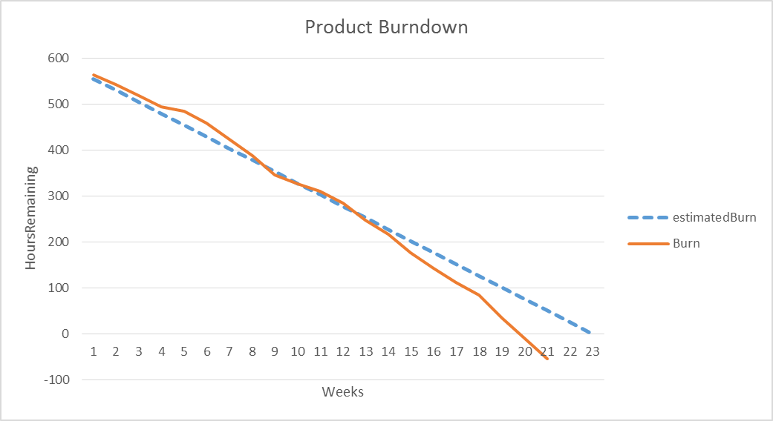

Sprint Burndown Chart

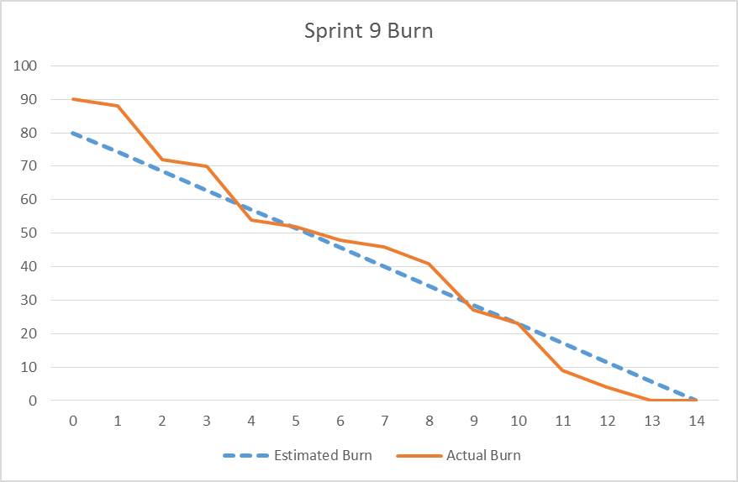

Weekly Development Effort

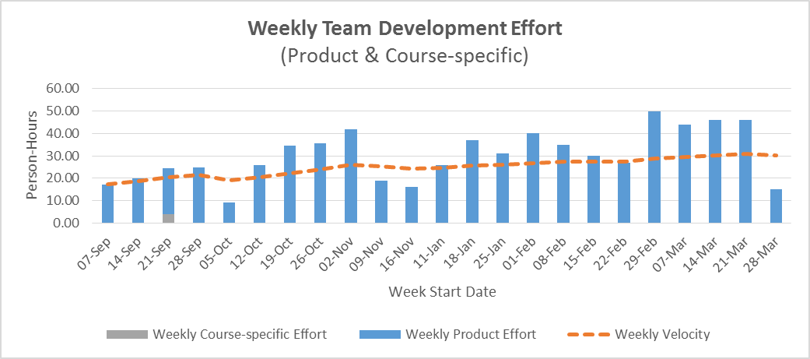

Daily Team Effort

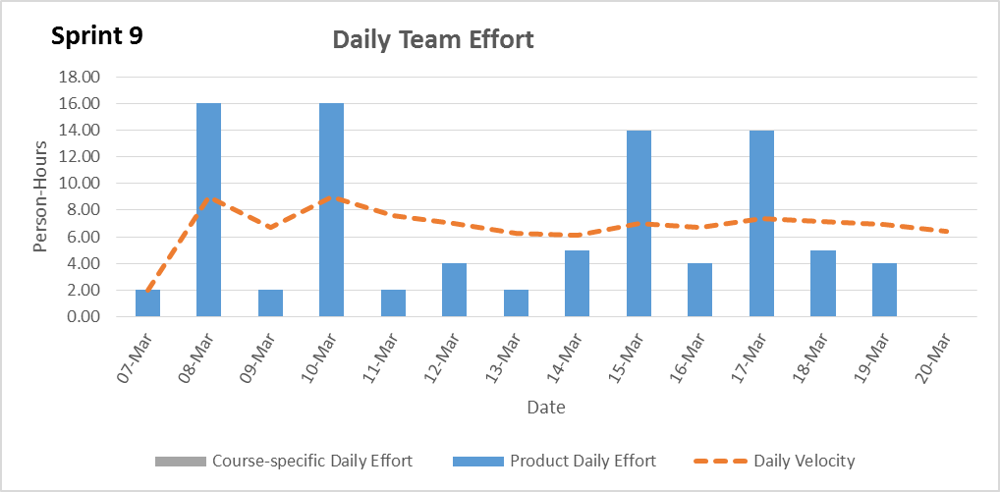

Team Member Effort

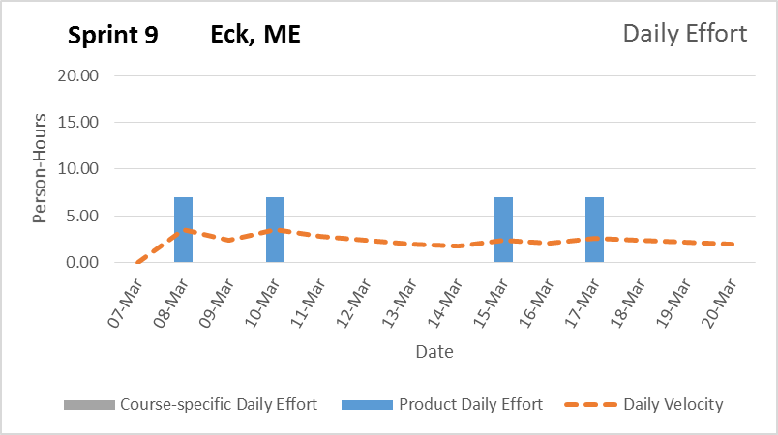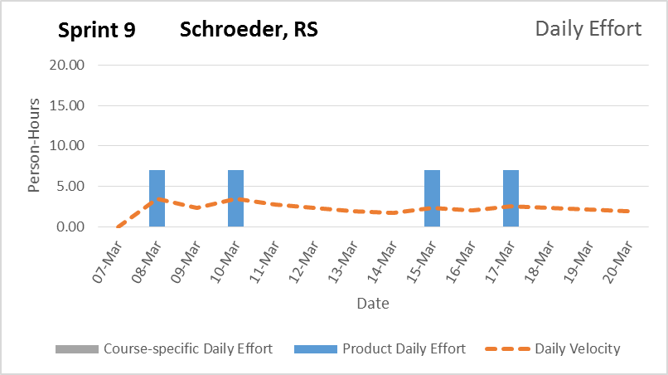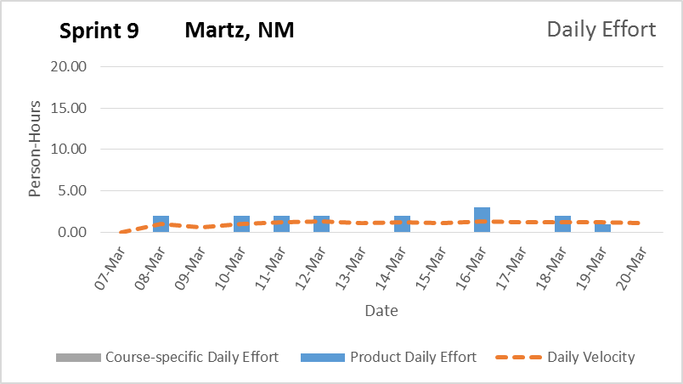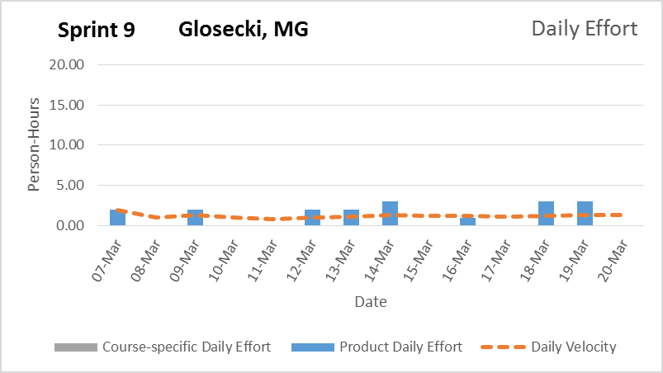

6. The team believes the browser version of this page will be complete with all functionality, however without a server a mobile application cannot be developed.

Signature Date

__________________________________________ ______________

__________________________________________ ______________

__________________________________________ ______________

__________________________________________ ______________

